6 Types of Communication
The types of communication represent the different ways used to communicate messages while the modes of communication focus on the mediums. Here are the 6 unique types of communication:

Verbal Communication
Through spoken words and the use of speech and language to convey messages. It occurs when we speak to others. Verbal communication can be formal and informal. However, when it takes place in person, verbal communication and non-verbal communication go together.

Non-Verbal Communication
Body language, facial expressions, eye contact, appearance, sign language. Non-verbal communication complements verbal communication and also helps when words don’t help. It is an important type of communication in interviews and discussions as they value a lot.

Written Communication
The use of written words to convey messages. Written communication happens through email, memos, texts, posts, etc. While written communication helps you share your thoughts well, sometimes it does not fully convey the emotion that you are trying to share.

Listening
Listening is one of the most important parts of communication as it helps you understand the perspective of the communicator and effectively engage with them. The process of any communication takes a crucial value at listening correctly and responding appropriately.

Visual Communication
Through visual messages like pictures, graphs, objects and other visual facets. Visual Communication is a crucial part of today’s methods of conveying important information. It is used in presentations, televisions, etc.

Various Cultural and Intercultural Modes of Communication
Several cultural modes of communication are specific to each area and culture. It can be symbolic usage of actions, body language, etc. The culture of a person is not just what they eat or wear but also how they communicate.

What are the Five Modes of Communication?
Communication is the process of sharing information between individuals using a set of common rules, behaviour, symbols, and signs. Thus, there are three modes of communication:
- Interpretative Communication
- Presentational Communication
- Interpersonal Communication
- Verbal Communication
- Non-Verbal Communication
Before we delve deep into the topic, let us first understand the importance of different modes of communication.
- Maintains the flow of conveying information
- Helps in devising plans and strategies for reaching a goal
- Builds cordial relations and soft skills
- Decision making becomes more effective and less time-consuming
- Problem-solving and conflict management becomes easier

Interpretive Communication
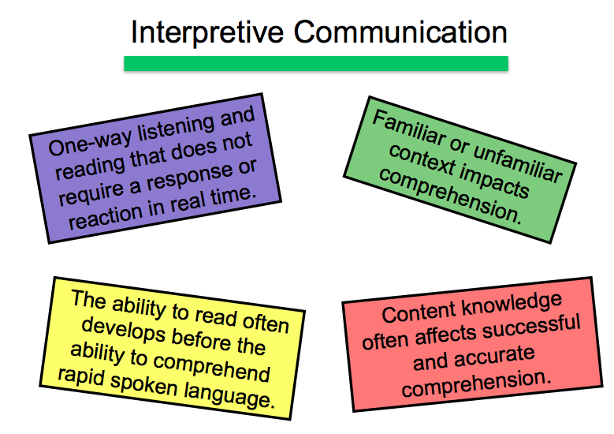Credit: Pinterest
Also referred to as the “one-way communication”, in this mode, the information conveyed by the sender is interpreted by the receiver in its original form. The target has to understand the message in both written and spoken form keeping various aspects in mind. For example, in a class, the learners may not understand every word said by the teacher but are expected to understand the main crux of the topic. Some of the main highlights of Interpretative Communication are:
- Learners understand, interpret, and analyze what is heard, read, or viewed on a variety of topics.
- This mode of communication involves interpreting the author or producer’s intent.
- There is no alternative to the active negotiation of meaning with the writer, speaker, or the producer.

Interpersonal Communication
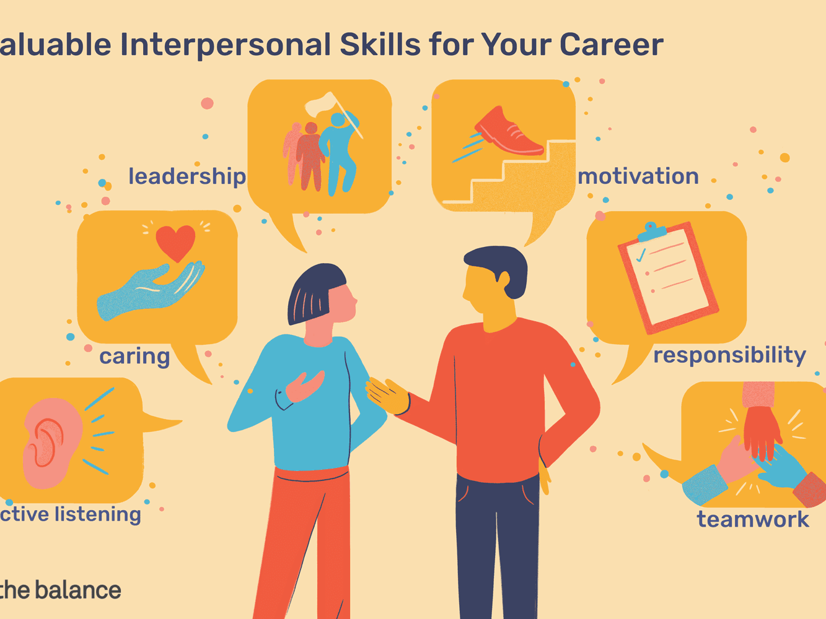Credit: Balance Careers
Interpersonal communication is the process by which people exchange information through verbal and nonverbal messages. It is an unmediated mode of communication that occurs when we interact and attempt to mutually influence each other, simultaneously, in order to manage relationships. Although interpersonal communication can encompass oral, written, and non-verbal forms of communication, the term is usually applied to spoken communication that takes place between two or more individuals on a personal or face to face level. Examples of Interpersonal Communication include:
- Personal Interview
- Telephonic Conversations
- Interactive Sessions
- Debates
- E-mails
- Text Messages
Models of CommunicationBachelor of Mass Communication

Presentational Communication
Presentational Communication is another type of one-way communication, which facilitates interpretation by members of another group where no direct opportunity for the active negotiation of meaning between members of the two groups exists. With this mode of communication, a person is speaking to an audience that can be rehearsed, pre-prepared, or scripted. Some of the main highlights of Presentational Communication have been given a rundown below.
- To ensure the intended audience is successful in its interpretation, the “presenter” needs knowledge of the audience’s language and culture.
- No direct opportunity for engaging with larger audience exists in this form of communication.

Multimodal Communication
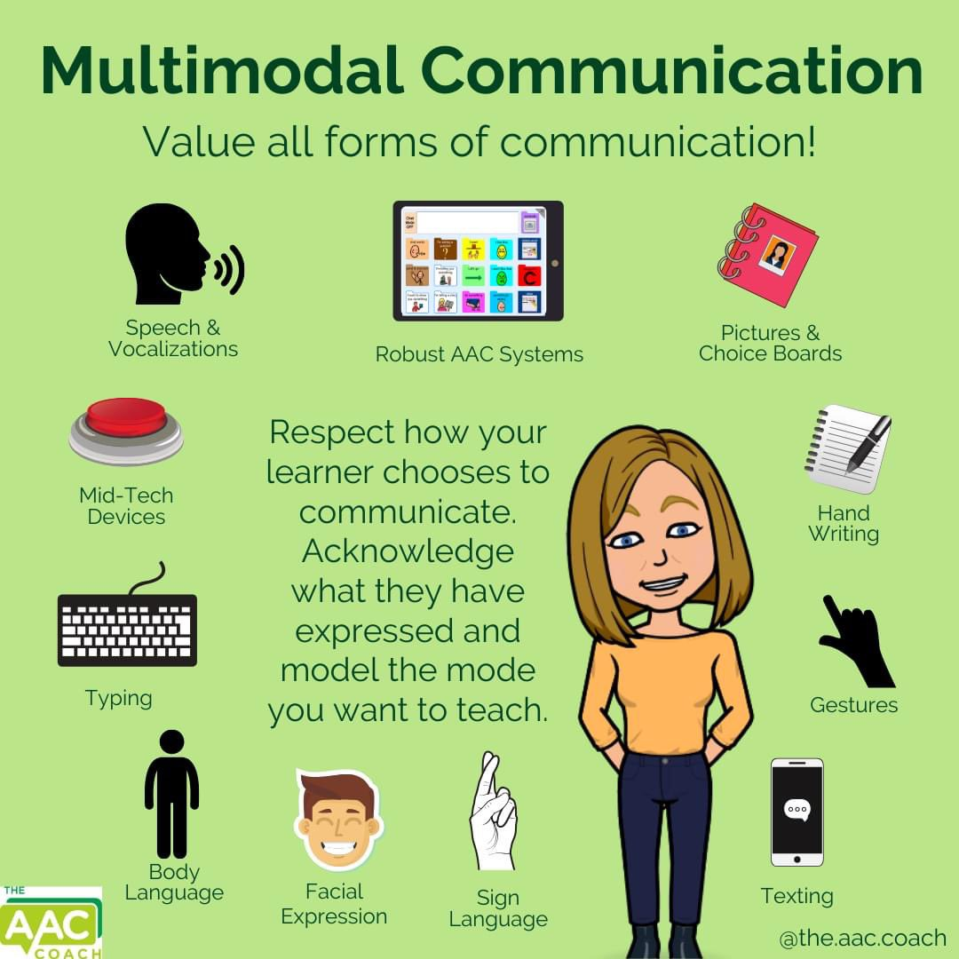Credit: Twitter
Multimodal Communication can be simply referred to as communication through varied modes such as verbal, written, gestures, etc. There are different modes under multimodal communication and it is popularly used in higher education to accentuate the learning experience for students. Here are the major 5 modes of communication:
- Linguistical or Alphabetic: Either written communication or spoken communication
- Gestural: Using Gestures
- Visual: Pictures, Videos, Infographics
- Aural: Audio, Music, Sounds
- Spatial: Physical coordination, positions, proximity

Linguistical or Alphabetic Communication
As one of the popular modes of communication, Linguistical or Alphabetic Communication mainly refers to written or spoken communication where the sender conveys their message through writing on a paper or through speaking.
Examples: Text messages, audio messages, emails, speech, notes and lists, etc

Gestural Communication
Gestural Communication has its quintessential emphasis on body language and physical movements to communicate messages. Sign Language is the best example for the gestural mode of communication as those who can’t talk or hear are able to communicate best through their gestures and have their own set of unique language to converse in. While this mode of communication is mainly combined with spatial, aural or linguistic ones, it can also be used individually given that both the sender and receiver have common points of references and meanings to have an understandable communication.

Aural Communication
As the name suggests, aural communication uses audio mode to convey messages whether it is through sounds or spoken audios. The speaker’s voice and pronunciation need to be clear and precise with no background noise.
Example: Radio, audio messages, music, recordings, songs, audiobook.

Visual Communication
Visual Communication can be simply termed as non-verbal communication as it comprises visual messages from the sender to the receiver. It is one of the oldest modes of communication when the ancient people didn’t know a language to communicate with, it is through pictures, drawings and symbols that they were able to talk and converse with each other.
Examples: Pictures, Videos, Charts, Graphs, Symbols

Spatial Communication
Spatial Communication elaborates upon the use of physical space in text as well as its overall structure to convey certain meanings and messages. The physical layout of any written text is deliberately designed to make it look a certain way and adhere to a particular theme. Websites also use this unique mode of communication in choosing a certain font, style, design and layout to make any website user-friendly and more interactive.

Modes of Communication: Key Differences
Components | Interpersonal | Interpretive | Presentational
Type | Two-way mode of communication | One-way communication | One-way communication
Negotiation | Active negotiation ofmeaning between individuals | No active negotiation of meaning with the writer,producer or speaker | No plausible means of engaging the masses
Mode of Communication | Speaking, Listening, Reading, and Writing are the main modes of conveying and interpreting messages | Reading, Viewing, and Listening texts | Writing and Speaking are the 2 major modes of communication
Examples | Social Media, text messages, telephone, etc. | Stories, literature, articles, speeches, songs, radio news, videos, movies,presentations, etc. | Articles, flyers,short stories,reports, presentations, skits, debates, speeches, etc

10 Modes of Communication
Different types of communication methods are used to deliver your message. Here, the 10 modes of communication are different from the previous ones. Interpersonal, interpretive, and presentational modes of conversation are based on human interaction during that communication. While these modes of communication are based on the type of source we use for communication. These are some of the real-world communication methods. Let’s have a look at them:
- Typewriting only– In this method, communication happens only through typing. Examples are emails, messages, etc.
- Handwriting only– Here the communication from both ends is solely based on handwriting. An example is a teacher correcting a student’s exam paper and writing comments in it.
- Voice only– Here, both the communicators use voice only. An example is a phone call or a normal verbal communication
- Video only– Here, both the communicators use video to communicate. An example is a video call
- Handwriting and Typing– Here either one of the communicators is using handwriting to share their message and the other is using typing to relay their response or vice versa.
- Typewriting and Video– Here either one of the communicators is using handwriting to share their message and the other is using typing to relay their response or vice versa.
- Handwriting and Video-Here either one of the communicators are using handwriting to share their message and the other is using video to relay their response or vice versa.
- Voice and Typewriting– Here either one of the communicators are using voice to share their message and the other is using typing to relay their response or vice versa.
- Voice and Handwriting-Here either one of the communicators is using voice to share their message and the other is using handwriting to relay their response or vice versa.
- Voice and Video-Here either one of the communicators is using voice to share their message and the other is using video to relay their response or vice versa.

Cultural Differences in Communication
In verbal communication, different cultures have different languages, dialects, and even accents. Even the tone and volume of communication differ from place to place. For example, the tone of a native German speaker might angry with a British speaker, even if they both are speaking in English.
In non-verbal communication, several differences can cause miscommunication in intercultural discussions. Some of the major non-verbal modes of communication that change from place to place are:
- Touch
- Eye Contact
- Gestures
- Facial Expressions
- Physical Space
- Posture

